**Spark Operator Components Maintenance:**

**Delete Spark Operator Components for Tenants which does not require Spark:**

1. For example, Select the tenant which does not require Spark components

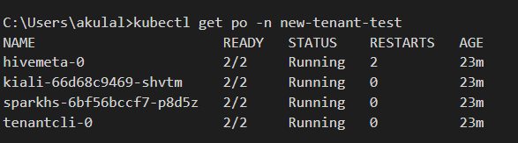

1. Check the tenant is listed under tenant object

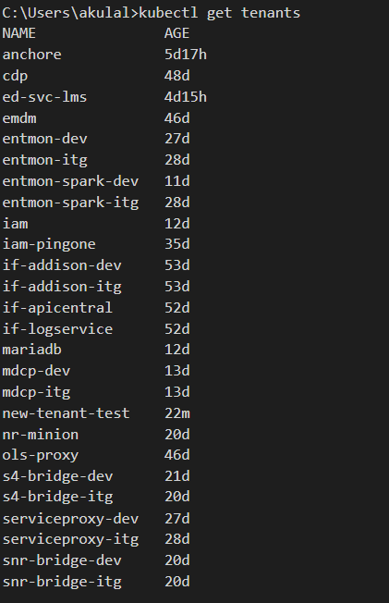

1. Delete the tenant from the tenant object and validate that the Spark Operator components are terminated.

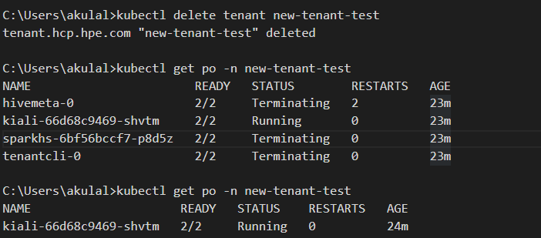

**Create Spark Operator Components for a Tenant manually:**

To create the spark components, we will need to create the tenant object for the namespace.

1. Grab the tenant id for which you need to create spark components using:

***$ kubectl get ns <namespace-name> -L hpecp.hpe.com/hpecptenant***

Example:

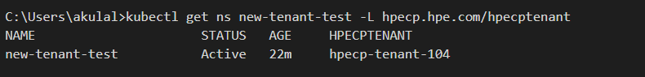

Here ***hpecp-tenant-104*** is the tenant id of ***new-tenant-test*** tenant

1. Edit the ***CreateSparkComponents.yaml*** file (attached in the email thread) and update the below:

* metadata.name: <namespace-name>
* spec.grouplist:   
  - <tenant id>-member

- <tenant id>-admin

Example:

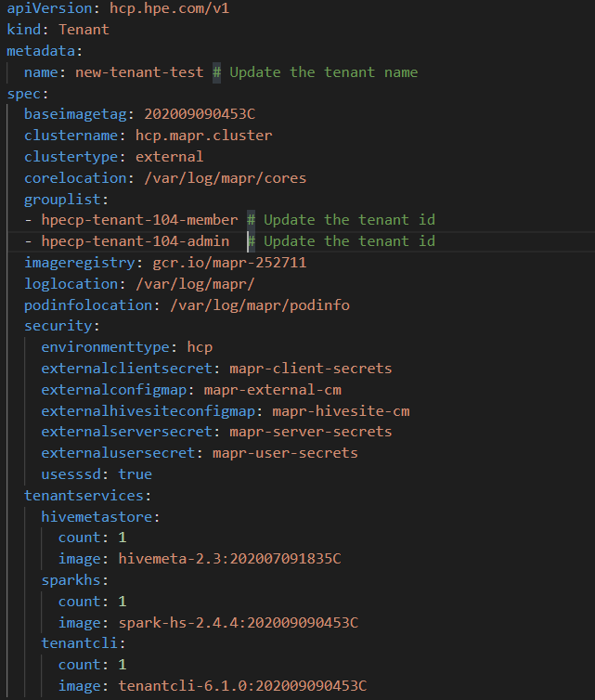

1. Apply the edited ***CreateSparkComponents.yaml*** file.

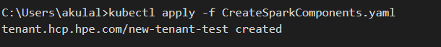

1. Check if the tenant object and the spark components are created

